Nama : Vony Ayu Anggraeni

Kelas : 5B

Nim : 18090100

**Source Code**

⦁ Web.php : application/controllers

⦁ v_header.php : application/views

⦁ v_index.php : application/views

⦁ v_footer.php : application/views

⦁ v_about.php : application/views

**Url**

<http://localhost/pustaka_booking_vony/Web>

<http://localhost/pustaka_booking_vony/index.php/Web/about>

**Capture Hasil**

Web.php

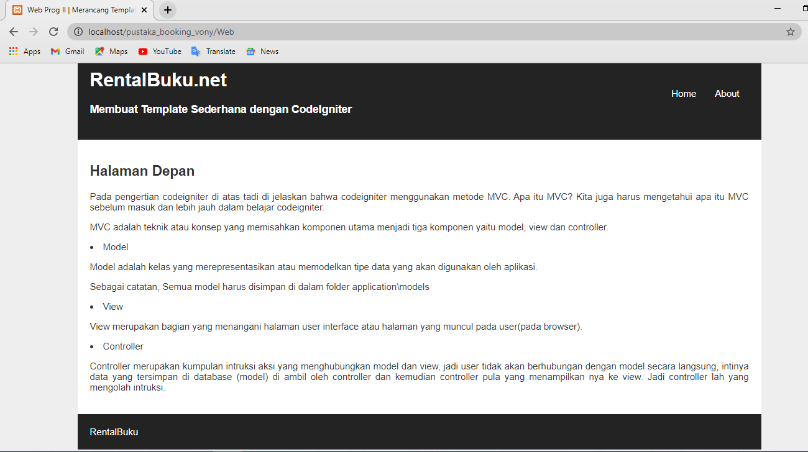

v_about.php

